Basic SQL queries exercise

Topics:

Basic SQL commands (DDL and DML)

Constraints

Create tables:

Table 1:
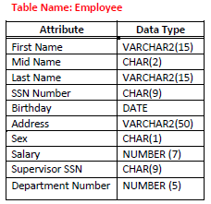

Create table employee:
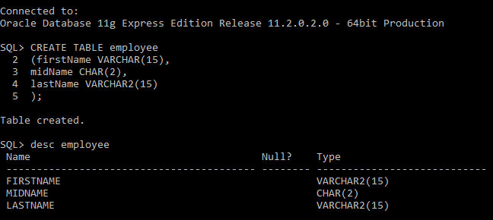
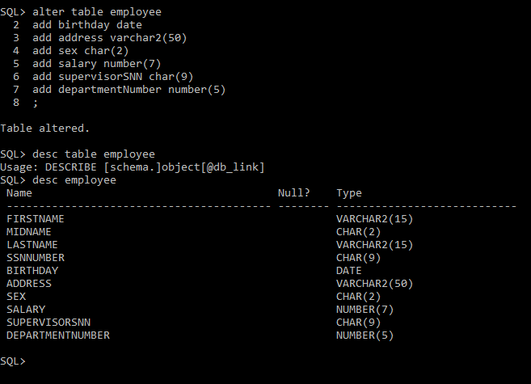

Table 2:
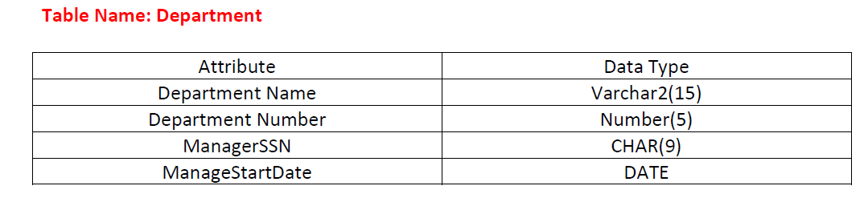

Create table department:
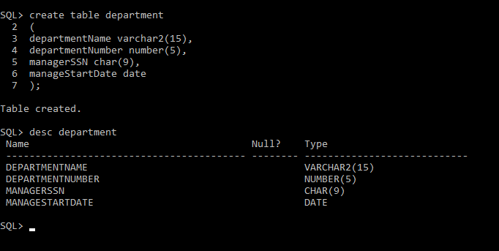

Table 3:
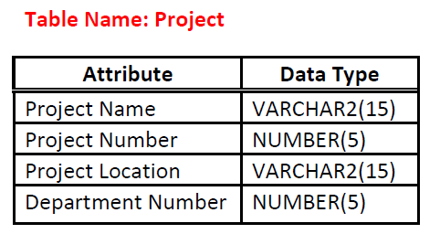

Create table project:
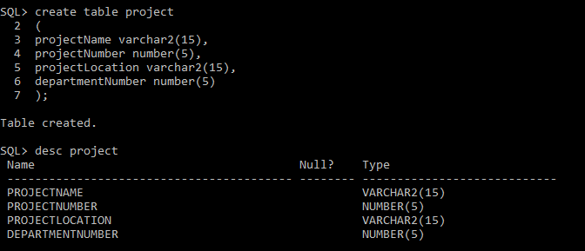

Q 1- Insert the data given above in employee, department and project tables.

Data insertion for table employee
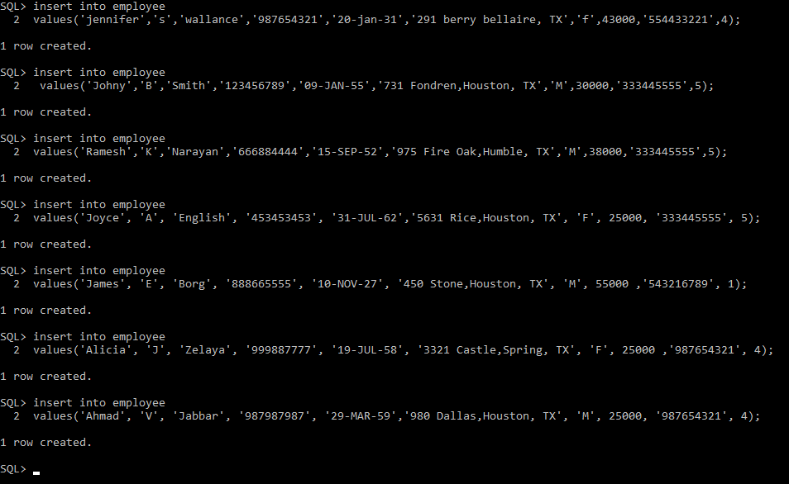

View table department
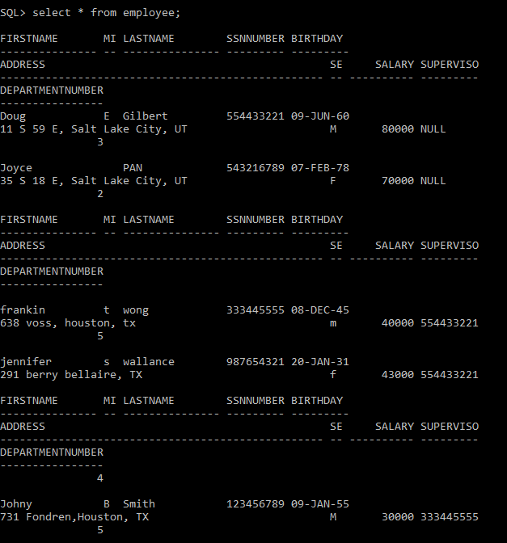
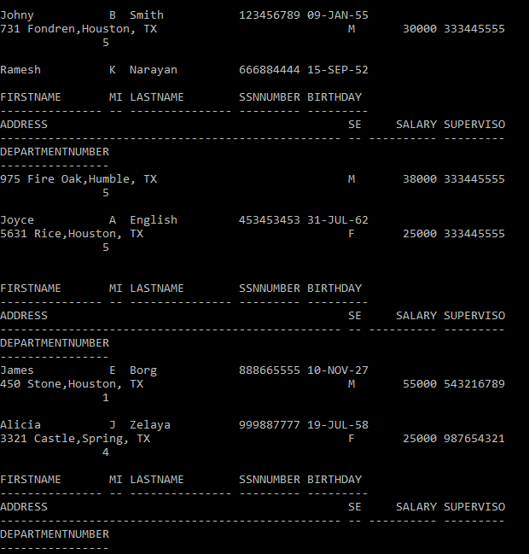
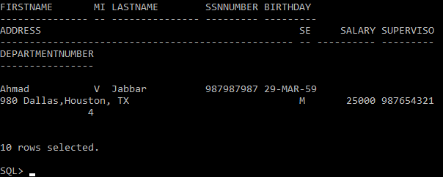

Data insertion for department table
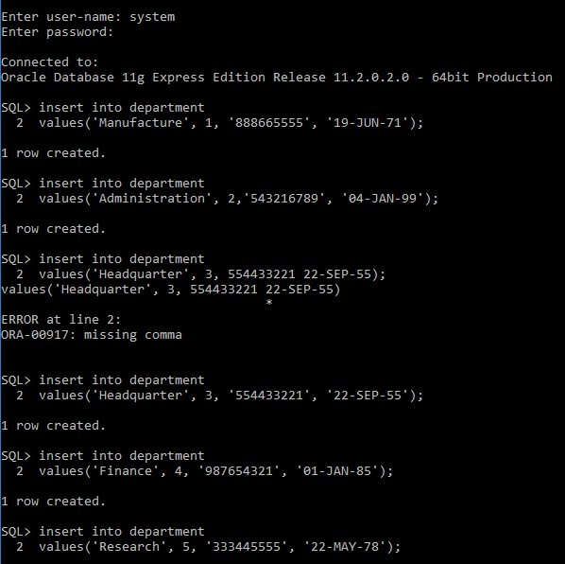

View department table:
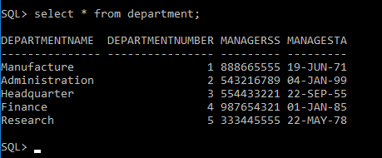
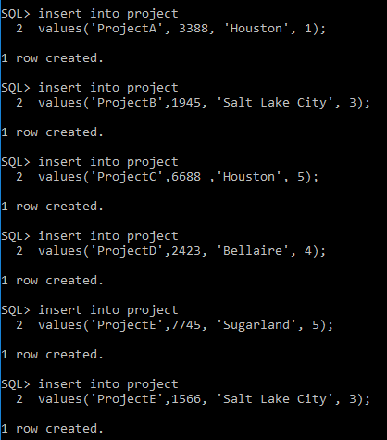

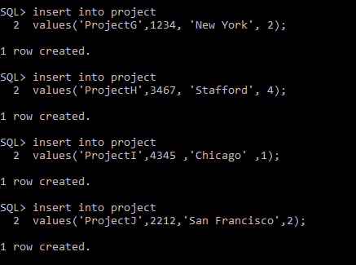

Table project
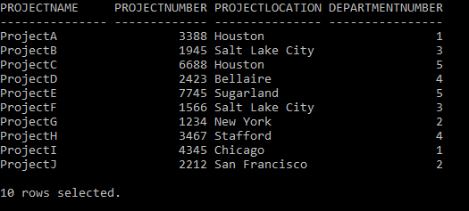

Q 2: Retrieve all the employees’ information for a particular department number: I retrieved for department number 5.
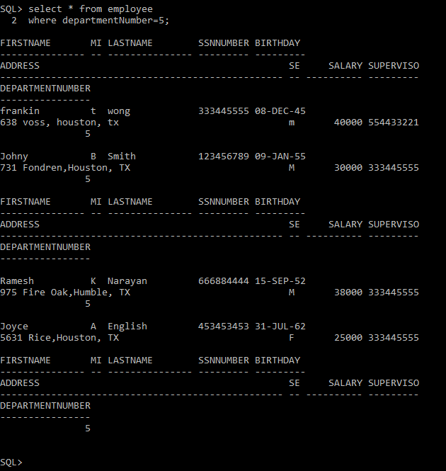

Q 3: Get Employee name along with his SSN and Supervisor SSN.
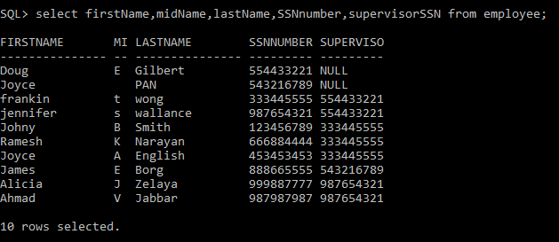

Q 4: Retrieve the employee names whose birthdate is ’29-MAR-1959’.
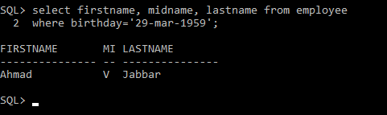

Q 5: Get salaries of the employees without duplications.

METHOD 1:
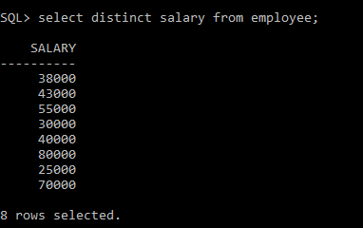
OR

METHOD 2:
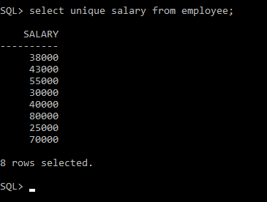
Note: Unique and Distinct serve the same purpose i.e. to fetch the non-duplicate aka unique aka distinct rows and CAN BE used INTERCHANGEABLY. However, UNIQUE is not a keyword as per SQL standards and is acceptable only in certain databases such as Oracle.

Q 6: Retrieve the MgrSSN, MgrStartDate of the manager of ‘Research’ department.
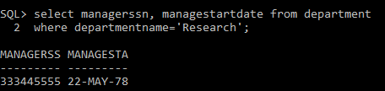

Q 7: Change the department number of an employee having fname as ‘Joyce’ to 3.
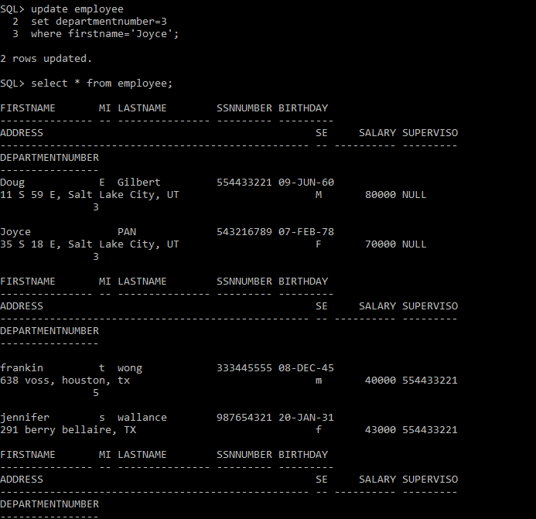
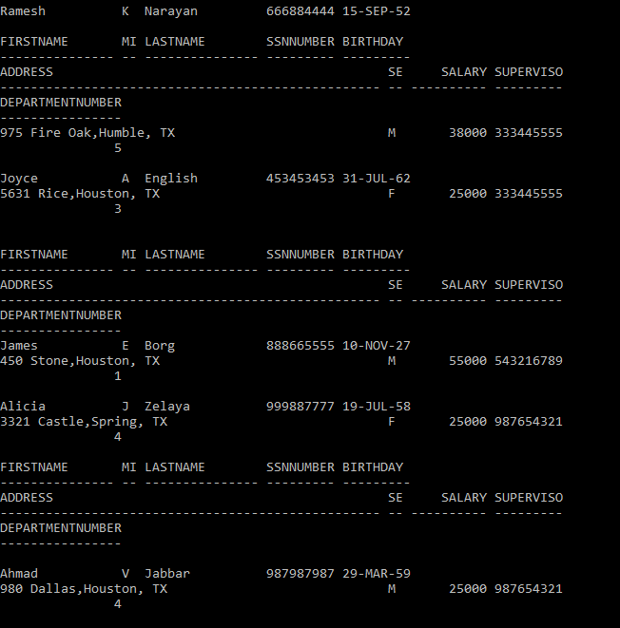
Note: Be careful when updating records in a table! Notice the WHERE clause in the UPDATE statement. The WHERE clause specifies which record(s) that should be updated. If you omit the WHERE clause, all records in the table will be updated!

Q 8: Alter Table department add column ContactNo of NUMBER data type and insert values into this column only.
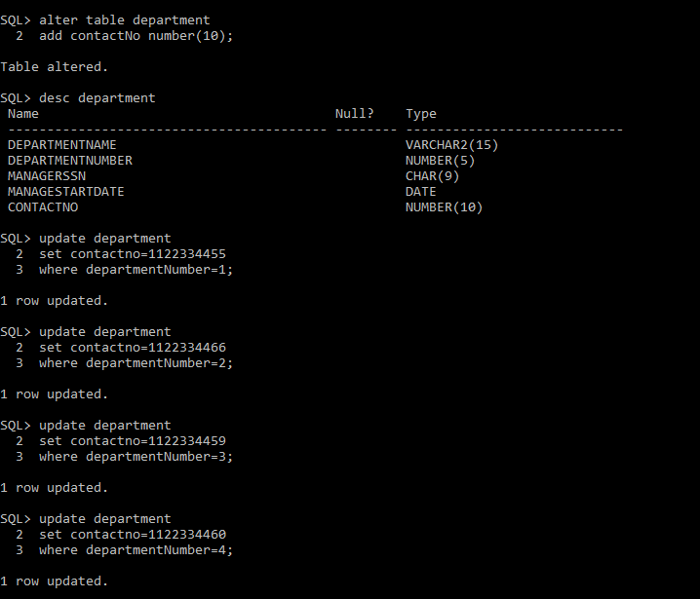
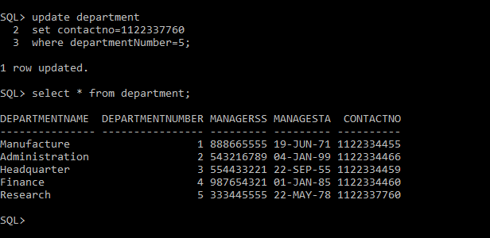

Q 9: Change table department by modifying the size of field ContactNo.
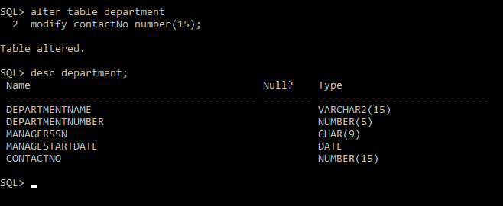

Q 10: Modify the field name ContactNo of departments table to MobileNo.
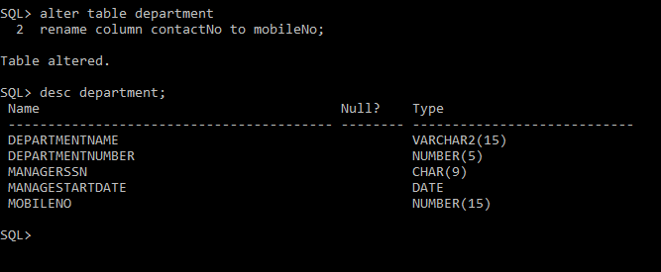

Q 11: Change name of Table Department to DEPT.
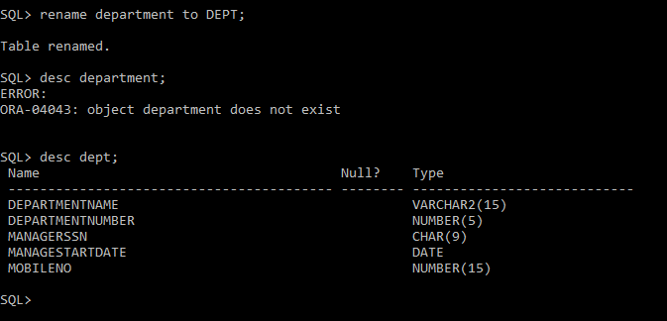

Q 12: Alter Table department by removing column MobileNo.
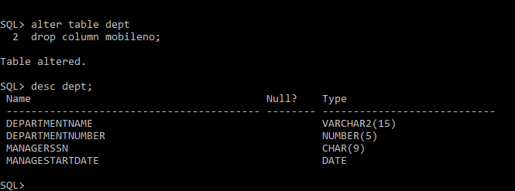

Q 13: Create a table COPYOFDEPT as a copy of the table DEPT.
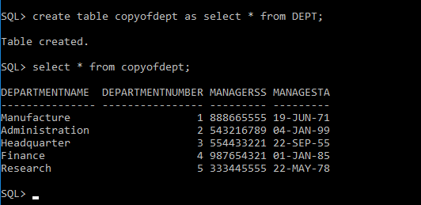

Q 14: Remove the rows from COPYOF DEPT table with department number as 5.
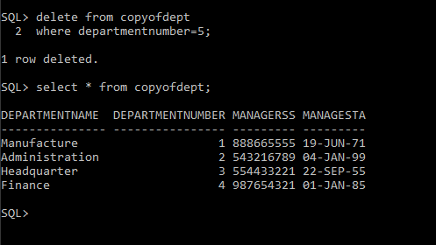

Q 15: Remove COPYOF DEPT table.
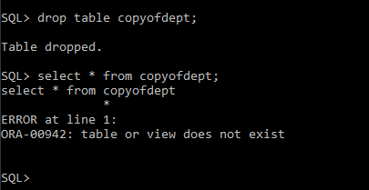

EXERCISE 2

Topic: Constraint

Alter existing tables to add constraints and make new tables

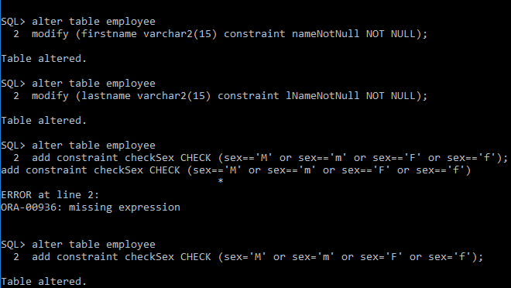

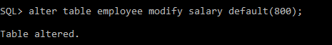


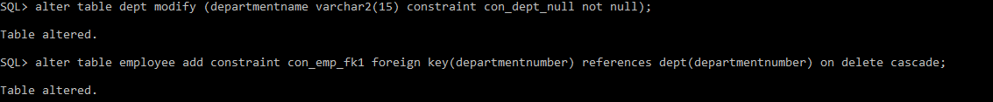
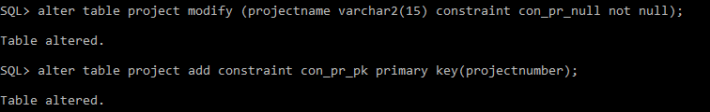
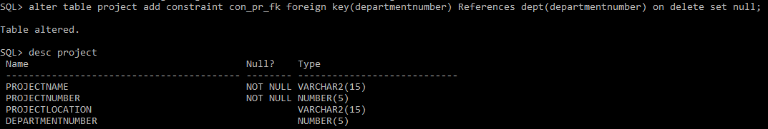

Create new tables

Create Table deptLocations
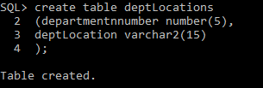
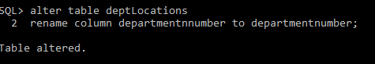

Insertion of values in table deptLocations:
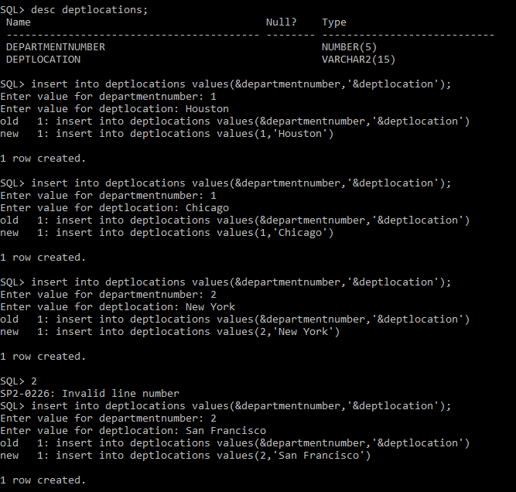
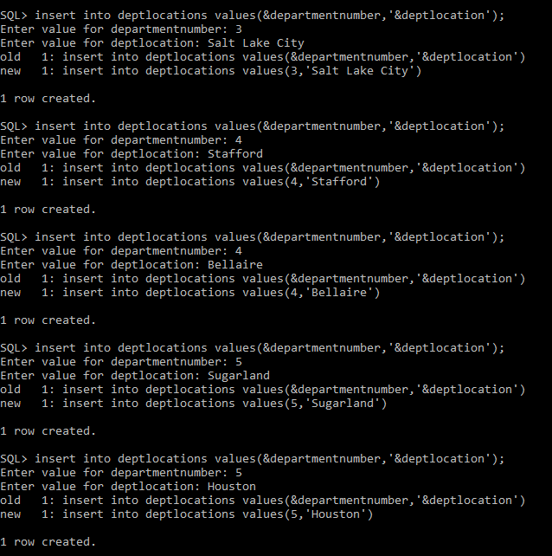

View table deptLocations
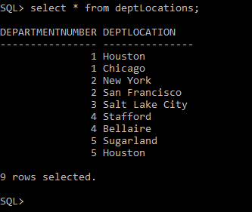

CREATE TABLE WORKSON:

Data Insertion for new tables:

EXERCISE 2 PART(I): Execute the following Queries on the Db to note the violations integrity constraints by any of the following operations:

Q1. Insert ('Robert', 'F', 'Scott', '987987987 ', '21-JUN-42', '2365 Newcastle Rd, Bellaire, TX', M, 58000, '888665555', 1 ) into EMPLOYEE.
Here we note that the constraint prevents us from inserting invalid input:

Q2. Insert ('Ramez', 'F', 'Scott', ' ', '21-JUN-42', '2365 Newcastle Rd, Bellaire, TX', M, 58000, '888665555', 1 ) into EMPLOYEE
Here we note that the constraint prevents us from inserting invalid input:

Q3. Insert ( '677678989', null, '40.0' ) into WORKS_ON.
Here we note that the constraint prevents us from inserting invalid input.

Q4. Insert ( '453453453', 'John', M, '12-DEC-60', 'SPOUSE' ) into DEPENDENT.
Here we note that the input is valid and it satisfies the constraints.

Q5. Insert ( '343453453', 'Varun',’’, '12-DEC-60', 'SON' ) into DEPENDENT.
Here we note that the constraint prevents us from inserting invalid inputs.

Q6. Delete WORKS_ON tuples with ESSN= '333445555'.
Here no constraint is violated so we are allowed to delete the tuples.

Q7. Modify MGRSSN and MGRSTARTDATE of the DEPARTMENT tuple with DNUMBER=5 to '123456789' and '01-OCT-88', respectively.
Here no constraint is violated so we are allowed to update the table dept.

EXERCISE 2 PART (II) - Alter the tables to:

Q1. Enforce Foreign Keys using Alter command [if not done earlier].
This has been done earlier. Please check the SETUP PART.

Q2. Remove foreign key defined on SuperSSN and enforce it again using Alter table command.

Q3. Make name of Project as Unique and sex of employee as not null.

Q4. Make salary of employee to accept real values.

